Building Site Surveying & Set Out 2
Semester 2 – 2003
Lecturer: Karl Boeing
Roll No 323393 - SIN 27755 - Room L1136

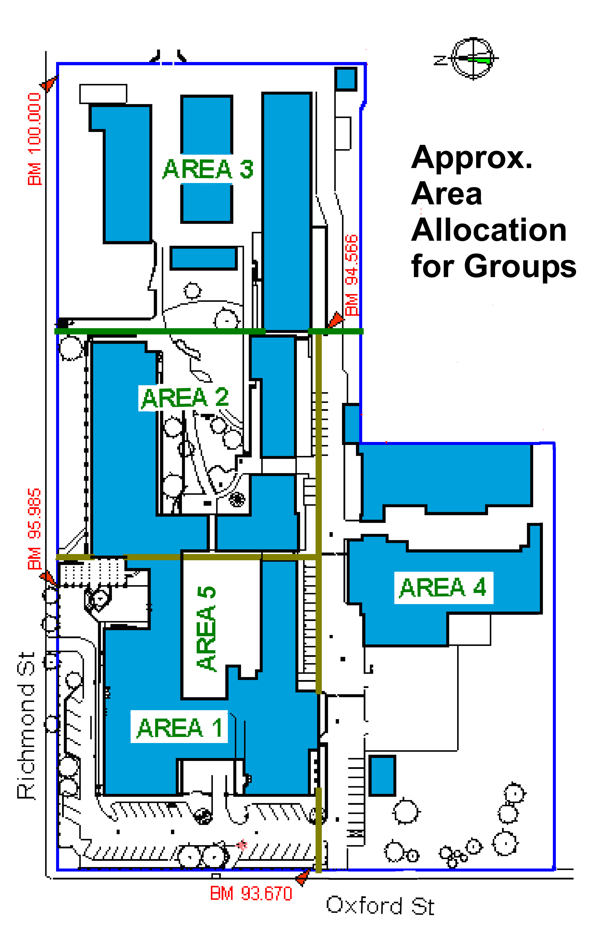

Group Area 1
James Burrows
Simon Grieco
Andrew Roberts

Group Area 2
Steven Ioppolo
Mark Piccoli
Scott Anderson

Group Area 3
Mark Adam
Jon Clements
Carl silver

Group Area 4
Garry Briggs-Bradford
Ryan Rafferty
Lennard Ostaszewskej

Group Area 5 (Courtyard)
Christopher Ratty
Ryan Hugh
Group 5 did not participate

